

oneM2M
Technical Report
Document Number | TR-0027-V-0.2.0
Document Name: | DDS usage in oneM2M system
Date: | 2016- December-15
Abstract: | This technical report aims to study how the advantages of the DDS protocol can be used in the oneM2M system to enhance the oneM2M platform perception of the whole system data capability and the oneM2M system realtime data transport performance, and further how the oneM2M system can interwork with the existing DDS system.
Template Version: 08 September 2015 (Dot not modify)

This Specification is provided for future development work within oneM2M only. The Partners accept no liability for any use of this Specification.
The present document has not been subject to any approval process by the oneM2M Partners Type 1. Published oneM2M specifications and reports for implementation should be obtained via the oneM2M Partners' Publications Offices.

About oneM2M
The purpose and goal of oneM2M is to develop technical specifications which address the need for a common M2M Service Layer that can be readily embedded within various hardware and software, and relied upon to connect the myriad of devices in the field with M2M application servers worldwide.
More information about oneM2M may be found at: http//www.oneM2M.org
Copyright Notification
© 2015, oneM2M Partners Type 1 (ARIB, ATIS, CCSA, ETSI, TIA, TSDSI, TTA, TTC).
All rights reserved.
The copyright and the foregoing restriction extend to reproduction in all media.

Notice of Disclaimer & Limitation of Liability
The information provided in this document is directed solely to professionals who have the appropriate degree of experience to understand and interpret its contents in accordance with generally accepted engineering or other professional standards and applicable regulations. No recommendation as to products or vendors is made or should be implied.
NO REPRESENTATION OR WARRANTY IS MADE THAT THE INFORMATION IS TECHNICALLY ACCURATE OR SUFFICIENT OR CONFORMS TO ANY STATUTE, GOVERNMENTAL RULE OR REGULATION, AND FURTHER, NO REPRESENTATION OR WARRANTY IS MADE OF MERCHANTABILITY OR FITNESS FOR ANY PARTICULAR PURPOSE OR AGAINST INFRINGEMENT OF INTELLECTUAL PROPERTY RIGHTS. NO oneM2M PARTNER TYPE 1 SHALL BE LIABLE, BEYOND THE AMOUNT OF ANY SUM RECEIVED IN PAYMENT BY THAT PARTNER FOR THIS DOCUMENT, WITH RESPECT TO ANY CLAIM, AND IN NO EVENT SHALL oneM2M BE LIABLE FOR LOST PROFITS OR OTHER INCIDENTAL OR CONSEQUENTIAL DAMAGES. oneM2M EXPRESSLY ADVISES ANY AND ALL USE OF OR RELIANCE UPON THIS INFORMATION PROVIDED IN THIS DOCUMENT IS AT THE RISK OF THE USER.

Contents
Contents 3
1 Scope 5
2 References 5
2.1 Normative references 5
2.2 Informative references 5
3 Definitions, symbols and abbreviations 6
3.1 Definitions 6
3.2 Symbols 6
3.3 Abbreviations 7
4 Conventions, 7
5 Introduction of DDS 7
5.1 Backgrounds 7
5.2 Status 8
5.3 Architecture and protocol stack 8
5.3.1 Data-Centric Publish-Subscribe (DCPS) 8
5.3.2 Real Time Publish subscribe (RTPS) 9
5.3.3 Common Object Request Broker Architecture (CORBA) 10
5.4 Key features 10
5.4.1 Quality of Service (QoS) Policy 10
5.4.2 Dynamic Discovery 11
5.4.3 Discovery in CORBA 12
5.5 Security 12
5.6 Benefits of introducing DDS to oneM2M 13
6 DDS protocol binding 13
6.1 DDS configuration within oneM2M Architecture 13
6.2 Solution 1 15
6.2.1 Overview 15
6.2.2 DDS repository co-located within oneM2Mnodes 16
7 Possible Solutions for DDS based direct change of data between oneM2M entities 17
7.1 Senarios for DDS based direct change of data between oneM2M entities 17
7.2 Solution 1 17
8 Possible Solutions for oneM2M and DDS system interworking 18
8.1 Senarios for oneM2M and DDS system Interworking 18
8.2 Solution 1 18
9 Conclusion 18
Proforma copyright release text block 18
Annexes 18
Annex <y>: Bibliography 19
History 19

1 Scope
This technical report aims to study how the advantages of the DDS protocol can be used in the oneM2M system to enhance the oneM2M platform perception of the whole system data capability and the oneM2M system realtime data transport performance, and further how the oneM2M system can interwork with the existing DDS system. The objectives of the Technical Report are as follows:
- Investigate the value and the feasibility of DDS protocol binding;
- Investigate how direct exchange of primitives between oneM2M entities without registration-relationship could be enabled such that it would benefit from real time data transport between the nodes under the centralized management of DDS topics, QoS policies and the publish/subscribe relations; and
- Investigate the interworking between the oneM2M system and the DDS system, e.g. how the DDS data space can be accessed by the oneM2M applications.
Each of the above objectives will be studied in a separate sub-clause, which may include scenarios and possible solutions. And at the end of this technical report, evaluation of all the solutions will be given and based on the conclusion, normative works may be followed as CRs to the existing TSes and one or more new TS may be proposed to specify the identified solution in this technical report.

2 References
The following text block applies.
References are either specific (identified by date of publication and/or edition number or version number) or non-specific. For specific references,only the cited version applies. For non-specific references, the latest version of the referenced document (including any amendments) applies.

2.1 Normative references
As a Technical Report (TR) is entirely informative it shall not list normative references.
The following referenced documents are necessary for the application of the present document.
Not applicable.

2.2 Informative references
The following referenced documents are not necessary for the application of the present document but they assist the user with regard to a particular subject area.
[i.1] oneM2M Drafting Rules (http://www.onem2m.org/images/files/oneM2M-Drafting-Rules.pdf)
[i.2] oneM2M TS-0001: "Functional Architecture".
[i.3] oneM2M TS-0004: "Service Layer Core Protocol Specification".
[i.4] oneM2M TS-0003: "Security Solutions".
[i.5] Data Distribution Service (DDS)
NOTE: Available at http://www.omg.org/spec/DDS/.
[i.6] Real-time Publish-Subscribe Wire Protocol DDS Interoperability Wire Protocol
NOTE: Available at http://www.omg.org/spec/DDSI-RTPS/.
[i.7] DDS Data Local Reconstruction Layer (DDS-DLRL)
NOTE: Available at http://www.omg.org/spec/DDS-DLRL/.
[i.8] Extensible and Dynamic Topic Types for DDS
NOTE: Available at http://www.omg.org/spec/DDS-XTypes/.
[i.9] DDS Security
NOTE: Available at http://www.omg.org/spec/DDS-SECURITY/.
[i.10] Remote Procedure Calls over DDS
NOTE: Available at http://www.omg.org/spec/DDS-RPC/.

3 Definitions, symbols and abbreviations
Delete from the above heading the word(s) which is/are not applicable.

3.1 Definitions
Clause numbering depends on applicability.
- A definition shall not take the form of, or contain, a requirement.
- The form of a definition shall be such that it can replace the term in context. Additional information shall be given only in the form of examples or notes (see below).
- The terms and definitions shall be presented in alphabetical order.
For the purposes of the present document, the [following] terms and definitions [given in ... and the following] apply:
Definition format
<defined term>: <definition>
If a definition is taken from an external source, use the format below where [N] identifies the external document which must be listed in Section 2 References.
<defined term>[N]: <definition>
example 1: text used to clarify abstract rules by applying them literally
NOTE: This may contain additional information.

3.2 Symbols
Clause numbering depends on applicability.
For the purposes of the present document, the [following] symbols [given in ... and the following] apply:
Symbol format
<symbol> <Explanation>
<2nd symbol> <2nd Explanation>
<3rd symbol> <3rd Explanation>

3.3 Abbreviations
Abbreviations should be ordered alphabetically.
Clause numbering depends on applicability.

For the purposes of the present document, the abbreviations given in oneM2M TS-0001 [i.2] and the following apply:
DDS Data Distribution Service
IoT Internet of Things
DCPS Data-Centric Publish-Subscribe
RTPS Real-time Publish-Subscribe
DLRL Data Local Reconstruction Layer
QoS Quality of Service

4 Conventions,
The key words “Shall”, ”Shall not”, “May”, ”Need not”, “Should”, ”Should not” in this document are to be interpreted as described in the oneM2M Drafting Rules [i.1]

5 Introduction of DDS

5.1 Backgrounds
The Data Distribution Service (DDS) is a middleware protocol and API standard for data-centric connectivity specified by Object Management Group (OMG). DDS provides low-latency data connectivity, high reliability, and a scalable architecture that business and mission-critical Internet of Things (IoT) applications need. DDS standards can be found on the OMG DDS website, where several features of DDS are illustrated, e.g. data centricity, global data space, quality of service, dynamic discovery and scalable architecture.
The core standards of DDS are the Data-Centric Publish-Subscribe (DCPS) [i.5] and the Real-time Publish-Subscribe Protocol (RTPS) [i.6]. The DCPS builds on the concept of a "global data space" that is accessible to all interested applications. Applications that want to contribute information to this data space declare their intent to become "Publishers". Similarly, applications that want to access portions of this data space declare their intent to become "Subscribers". This standard also specifies how Publishers and Subscribers refer to portions of this space. However, the DCPS does not address the protocol used by the implementation to exchange messages over transports such as TCP/UDP/IP, so different implementations of DCPS will not interoperate with each other unless vendor-specific "bridges" are provided. So the RTPS was specifically developed to be a standard publish/subscribe wire-protocol. The RTPS defines the message formats, interpretation, and usage scenarios that underlie all messages exchanged by applications.
OMG DDS Standards include the following series:
- Core
  - DDS [i.5] v1.4 – the DDS specification describes a DCPS model for distributed application communication and integration.
    - DDS-DLRL [i.7] v1.4 – describes a high-level Data Local Reconstruction Layer (DLRL) interface to DDS that allows a simple integration of the DDS Service into the application layer. The content of this specification is original part of the DCPS specification before v1.4, and was separated to construct a new specification in v1.4.
  - DDSI-RTPS [i.6] v2.2 – defines the RTPS DDS Interoperability Wire Protocol.
- Extensions
  - DDS-XTypes [i.8] v1.1 – defines Extensible and DynamicTopic Types for DDS
  - DDS-Security [i.9] v1.0 Beta 1 – defines the Security Model and Service Plugin Interface (SPI) architecture for compliant DDS implementations.
  - DDS-RPC [i.10] v1.0 Beta 1 – Defines a distributed services framework providing language-independent service defintion and service/remote procedure invokation using DDS. Supports automatic discovery, synchronous and asynchronous invocations, and QoS.
- Services
  - DDS-Web [i.11] v1.0 Beta 1 – defines a platform-independent Abstract Interaction Model of how web clients should access a DDS System and a set of mappings to specific web platforms that realize the Platform Independent Model (PIM) in terms of standard web technologies and protocols.
- API
  - ISO/IEC C++ 2003 Language PSM for DDS [i.12] – defines a C++ API only for the Data-Centric Publish-Subscribe (DCPS) portion of the DDS specification
  - Java 5 Language PSM for DDS [i.13] – defines a Java API for the Data-Centric Publish-Subscribe (DCPS) portion of the DDS specification.
  - Other language APIs for C, Java, Traditional C++, and other Languages are derived from the DDS API in IDL using the respective IDL to language Mappings
- Work in Progress
  - TCP/IP DDSI-RTPS PSM

5.2 Status
The work of the present document is based on the DDS released or in process specifications from OMG. The latest version and the correspongding time of the specifications are listed in table 5.2-1.
SPECIFICATION | acronym | version | Document state/date
Data Distribution Service | DDS | 1.4 | Released/2015-04
DDS Data Local Reconstruction Layer | DDS-DLRL | 1.4 | Released/2015-04
Real-time Publish-Subscribe Wire Protocol DDS Interoperability Wire Protocol | DDSI-RTPS | 2.2 | Released/2014-09
Extensible and Dynamic Topic Types for DDS | DDS-XTypes | 1.1 | Released/2014-11
DDS-SECURITY | DDS-SECURITY | 1.0 - Beta 2 | In Process/2016-06
Remote Procedure Calls over DDS | DDS-RPC | 1.0 - Beta 2 | In Process/2016-06
Web-Enabled DDS | DDS-WEB | 1.0 - Beta 2 | In Process/2015-12
ISO/IEC C++ 2003 Language DDS PSM | DDS-PSM-Cxx | 1.0 | Released/2013-11
Java 5 Language PSM for DDS | DDS-Java | 1.0 | Released/2013-11

5.3 Architecture and protocol stack

5.3.1 Data-Centric Publish-Subscribe (DCPS)
DCPS is specific to a "Data Centric" style of distributed communications, which leverages a publish/subscribe communications model to connect anonymous information producers with information consumers. The overall distributed application is composed of processes called "participants", each running in a separate global data space, possibly on different computers. Applications that want to contribute information to this data space declare their intent to become "Publishers". Similarly, applications that want to access portions of this data space declare their intent to become "Subscribers". Each time a publisher posts new data into this "global data space", the RTPS propagates the information to all interested subscribers.
The unit of information exchanged between publishers and subscribers is constructed following certain data model, which is identified by a topic and a type. The topic provides an identifier that uniquely identifies some data items within the global data space. The type provides structural information needed to tell the DCPS how to manipulate the data.
The "datawriter" is an logic function module, which is usually called "object" in DDS specifications, the application must use to communicate to a publisher. The publication is defined as the association of a datawriter to a publisher. To access the received data, the application must use a typed "datareader" attached to the subscriber. A subscriber may receive and dispatch data of different specified types to different datareader. Thus, a subscription is defined as the association of a datareader with a subscriber. When an application wishes to publish data of a given type, it must create a publisher (or reuse an already created one) and a datawriter with all the characteristics of the desired publication. Similarly, when an application wishes to receive data, it must create a subscriber (or reuse an already created one) and a datareader to define the subscription.
The overall DCPS entities is shown in Figure 5.3.1-1. All these DCPS entities are attached to a participant. A participant represents the local membership of the application in a domain. A domain is a distributed concept that links all the applications able to communicate with each other. It represents a communication plane: only the publishers and the subscribers attached to the same domain may interact.
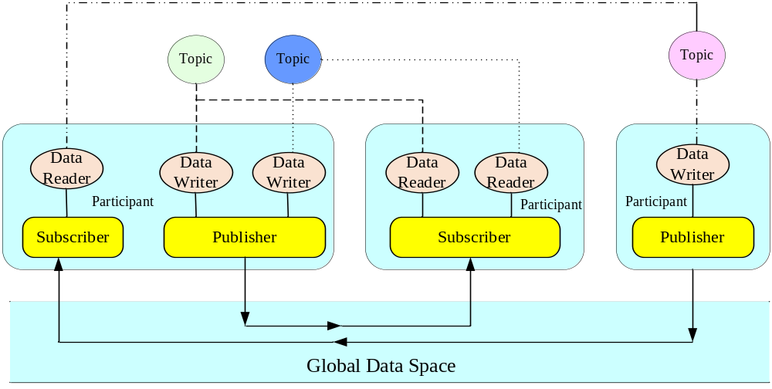
Figure 5.3.1-1 DCPS Entities

5.3.2 Real Time Publish subscribe (RTPS)
Real-time Publish-Subscribe Protocol (RTPS) allows Data Distribution Service (DDS) implementations from multiple vendors to interoperate. The RTPS protocol is designed to be able to run over multicast and connectionless best-effort transports such as UDP/IP.
The main features of the RTPS protocol include:
• Performance and quality-of-service properties to enable best-effort and reliable publish-subscribe communications for real-time applications over standard IP networks.
• Fault tolerance to allow the creation of networks without single points of failure.
• Extensibility to allow the protocol to be extended and enhanced with new services without breaking backwards compatibility and interoperability.
• Plug-and-play connectivity so that new applications and services are automatically discovered and applications can join and leave the network at any time without the need for reconfiguration.
• Configurability to allow balancing the requirements for reliability and timeliness for each data delivery.
• Modularity to allow simple devices to implement a subset of the protocol and still participate in the network.
• Scalability to enable systems to potentially scale to very large networks.
• Type-safety to prevent application programming errors from compromising the operation of remote nodes.

5.3.3 Common Object Request Broker Architecture (CORBA)
In some DDS open source realizations, the DCPS is implemented running over the CORBA, instead of RTPS. CORBA is a standard defined by OMG and is an architecture for data distribution using a broker. CORBA also defines a broker similar with MQTT. But when it is used in DDS, CORBA has a different running mechanism campared with MQTT. In DDS, there is a repository to discover other entity in the same service area. It seems like the server in CORBA. A repository has information of all participants in a domain such as a network address, identification, topic name and so on. As a client of CORBA, each participant can accesses and modifies data in a repository corresponding to each one.
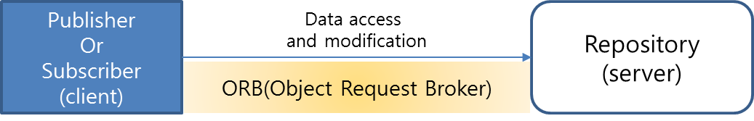

5.4 Key features

5.4.1 Quality of Service (QoS) Policy
DDS provides a rich set of Quality of Service (QoS) policies to allows applications to control/optimize network & computing resources. These QoS policies can be used individually or together to affect a variety aspects of communications, including reliability, performance, persistence of data, and amount of system resources used. These QoS policies makes DDS different from other communication middleware solutions.
The qualities of service (QoS) can be classified into six categories, such as data availability, data delivery, data timeliness, lifecycle, configuration and resources. The table below shows the full list of QoS policies available.
Table 5.4.1-1 DDS QoS Policies
QosPolicy | Meaning | Concerns | RxO | Changeable | Categories
USER DATA | Attaches arbitrary application data (a buffer of bytes) to discovery meta-data. | DP,DR,DW | NO | YES | Configuration
TOPIC DATA | Attaches arbitrary application data (a buffer of bytes) to discovery meta-data. | T | NO | YES | Configuration
GROUP DATA | Attaches arbitrary application data (a buffer of bytes) to discovery meta-data. | P,S | NO | YES | Configuration
LIVELINESS | Determine whether an Entity is "active" (alive). | T,DR,DW | YES | NO | Configuration
ENTITY FACTORY | Controls Entity behavior as a factory for other entities (i.e., if child entities are created enabled) | DP, P, S | NO | YES | Configuration
DEADLINE | Maximum duration within which an instance is expected to be updated. | T,DR,DW | YES | YES | Data  Timeliness
LATENCY BUDGET | Specifies the maximum acceptable delay from the time the data is written until the data is inserted in the receiver's applicationcache and the receiving application is notified of the fact. | T,DR,DW | YES | YES | Data  Timeliness
TRANSPORT PRIORITY | This policy is a hint to the infrastructure as to how to set the priority of the underlying transport used to send the data. | T,DW | N/A | YES | Data  Timeliness
READER_DATA_LIFECYCLE | Specifies the behavior of the DataReader with regards to the lifecycle of the datainstances it manages. | DR | N/A | YES | Lifecycle
WRITER_DATA_LIFECYCLE | Specifies the behavior of the DataWriter with regards to the lifecycle of the datainstances it manages. | DW | N/A | YES | Lifecycle
LIFESPAN | Specifies the maximum duration of validity of the data written by the DataWriter | T,DW | N/A | YES | Data  Availability
DURABILITY | Specifies if Connext will store and deliver previously published data to new/late-joining Readers. | T,DR,DW | YES | NO | Data  Availability
DURABILITY_SERVICE | Configures external Persistence Service for Writers with PERSISTENT or TRANSIENT Durability. | T,DW | NO | NO | Data  Availability
HISTORY | Controls how much data to store and how stored data is managed for the DataWriter/Reader within specified resource limits. | T,DR,DW | NO | NO | Data  Availability
TIME_BASED_FILTER | Sets minimum time period before new data for an instance is provided to a DataReader. | DR | N/A | YES | Resources
RESOURCE_LIMITS | Limits amount of data cached by the middleware. | T,DR,DW | NO | NO | Resources
RELIABILITY | Indicates the level of reliability offered/requested by the Service. | T,DR,DW | YES | NO | Data  Delivery
DESTINATION_ORDER | Controls the criteria used to determine the logical order among changes made by Publisher entities to the same instance of data. | T,DR | NO | NO | Data  Delivery
PRESENTATION | Controls how Connext presents data received by an application to DataReaders | P,S | YES | NO | Data  Delivery
OWNERSHIP | Specifies whether it is allowed for multiple DataWriters to write the same instance of the data and if so, how these modifications should be arbitrated. | T,DR,DW | YES | NO | Data  Delivery
OWNERSHIP_STRENGTH | Specifies strength used to arbitrate among multiple DataWriters of same instance. | DW | N/A | YES | Data  Delivery
PARTITION | Set of strings that introduces a logical partition among the topics visible by the Publisher and Subscriber. | P,S | NO | YES | Data  Delivery
RxO = Request/Offered Semantics, T = Topic, DP = DomainParticipan,
DR = DataReader, DW = DataWriter, P = Publisher, S = Subscriber

5.4.2 Dynamic Discovery
DDS provides a dynamic discovery service. Based on the discovery service, entities can discover and possibly keep track of the presence of remote entities. This discovery information is made available to the application through DDS built-in topics. Built-in Topics are a special kind of topics that are used by applications to discover each other. These Topics are handled automatically by the DDS middleware.
The dynamic discovery makes the DDS applications extensible. The application does not need to know or preconfigure the information of other entities for communication, e.g. IP address, because these information can be automatically discovered by dynamic discovery mechanism.
The dynamic discovery takes place using "built-in" DDS DataReaders and DataWriters with pre-defined Topics and QoS. There are four pre-defined built-in Topics: "DCPSParticipant", "DCPSSubscription", "DCPSPublication", and "DCPSTopic". For each of the built-in Topics, there exists a corresponding DDS built-in DataWriter and DDS built-in DataReader. The built-in DataWriters are used to announce the presence and QoS of the local DDS Participant and the DDS entities it contains (DataReaders, DataWriters and Topics) to the rest of the network. Likewise, the built-in DataReaders collect this information from remote Participants, which is then used by the DDS implementation to identify matching remote entities. The built-in DataReaders act as regular DDS DataReaders and can also be accessed by the user through the DDS API.
The RTPS Simple Participant Discovery Protocol (SPDP) detects and announces the presence of Participants in a domain. For each participant, the SPDP creates two RTPS built-in Endpoints: the SPDPbuiltinParticipantWriter and the SPDPbuiltinParticipantReader. The SPDPbuiltinParticipantWriter periodically sends SPDPdiscoveredParticipantData to a pre-configured list of locators to announce the participant’s presence on the network. The pre-configured list of locators may include both unicast and multicast locators. These locators simply represent possible remote Participants in the network, no Participant need actually be present. By sending the SPDPdiscoveredParticipantData periodically, participants can join the network in any order.

5.4.3 Discovery in CORBA
In case CORBA is used to transport, the DDS system uses the repository to discover the other entities. New publisher or subscriber creates a message which includes the built in topic by DCPS and the message is delivered to the repository. A repository collects information of all entities in a same domain and do the topic matching. Once a matching is established, a repository distributes matching information to publishers such as each entities' address , id and so on. When a publisher received these information, a publisher sends an association message to a subscriber. a subscriber checks received message. If this message is correct, the association is established and all data from a publisher will deliver to the subscriber directly.
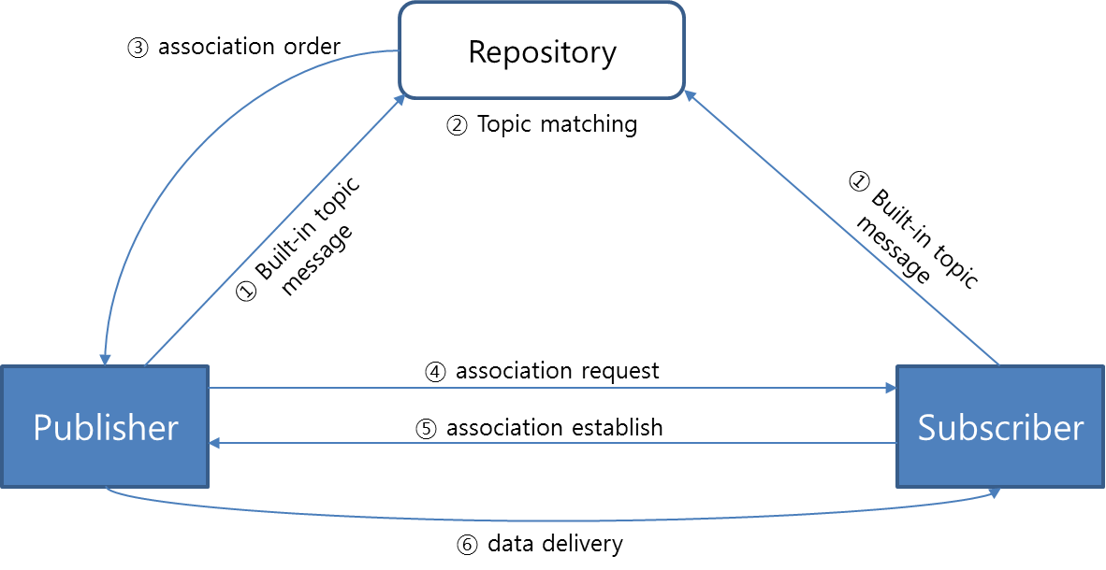
Figure 5.4.3-1 CORBA discovery scenario

5.5 Security
The security specification defines five Service Plugin Interfaces (SPIs) that when combined together provide Information Assurance to DDS systems:
• Authentication Service Plugin. Provides the means to verify the identity of the application and/or user that invokes operations on DDS. Includes facilities to perform mutual authentication between participants and establish a shared secret.
• AccessControl Service Plugin. Provides the means to enforce policy decisions on what DDS related operations an authenticated user can perform. For example, which domains it can join, which Topics it can publish or subscribe to, etc.
• Cryptographic Service Plugin. Implements (or interfaces with libraries that implement) all cryptographic operations including encryption, decryption, hashing, digital signatures, etc. This includes the means to derive keys from a shared secret.
• Logging Service Plugin. Supports auditing of all DDS security-relevant events
• Data Tagging Service Plugin. Provides a way to add tags to data samples.

5.6 Benefits of introducing DDS to oneM2M
It is considered that oneM2M can utilize the advantages of DDS in the following three different ways to adapt various scenarios.
  - The DDS binding makes use of DDS to provide reliable communications between two parties (AEs and CSEs). Similar to MQTT binding, the pub-sub relationship is established according to the topic names. Moreover, in DDS protocol binding, the pub-sub relationship is also established based on the dynamic discovery mechanism. Parties broadcast the information of topics which they want to publish or subscribe and receive the information of topics broadcasted by other parties. Once a topic which will be published by a party matches a topic which will be subscribed to by other parties, the pub-sub relationship is established. The establishment of a pub-sub relationship between Parties totally depends on the matching of topic names. However, this DDS binding solution may lead to some problem. If the setting of topic name is restricted to the format of "/<originator>/<receiver>" and the and the communication of parties depends on the registration relationship, the advantages of DDS protocol can not be fully utilized. On the other hand, if there is no restriction on the format of the topic name and the establishment of communication entirely depends on the dynamic discovery mechanism, the communication mechanism in oneM2M system will not depend on the registration relationship anymore and the central control capability of the oneM2M platform will be weakened. For example, two ADNs can communicate with each other directly through the dynamic discovery. This straight forward DDS protocol binding solution will be studied in clause 6.
  - For the above-mentioned problem, an optimized dynamic discovery solution is introduced in clause 7 for DDS based direct change of data between oneM2M parties. The optimized dynamic discovery mechanism is used to establish pub-sub relationship between parties using DDS repository which is the logic function module. The DDS repository is similar to the broker of MQTT. But there are two differences. Firstly, the DDS repository is only used to establish the pub-sub relationship, and doesn't forward the data from one party to another. Secondly, the DDS repository establishes the pub-sub relationship not only rely on topic name, but also taking the communication rules or policies into account. The communication rules or policies can be pre-configured according to the actual deployment scenario requirement, e.g. whether or not allowing two nodes without registration relation establish pub-sub relationship. The DDS repository can be implemented by different oneM2M nodes and can be deployed either distributed or in a central mode. In addition of enabling the oneM2M system to achieve low latency and high reliability adavantage of DDS protocol, this solution maintains the central control capability of the platform to the whole oneM2M system.
  - The DDS interworking solution will be studied in clause 8. It enables the oneM2M application to access the data of an existing DDS system. It enhances the interoperability of the oneM2M system, and thus oneM2M system can be used in more high demand scenarios, such as medical, smart energy, industry and so on. More real time systems and devices can be integrated into the oneM2M system.

6 DDS protocol binding

6.1 DDS configuration within oneM2M Architecture
When oneM2M system supports DDS, if a M2M device accesses the oneM2M system, it should firstly send topics (which can be represented as oneM2M resource), that it wants to publish or subscribe, to DDS repository which is used to provide the centralized control sevice and can be deployed on MN or oneM2M sevice platform. DDS repository stores these topics and establishes the pub-sub relationship according to the matching of topics based on the oneM2M architecure, which defined whether the publisher and the subscriber are allowed to establish the pub-sub relationship. Simply speaking, an entity publishes a topic is called a publisher, an entity subscribes the topic is called a subscriber. In case the topic name of a publisher is same with the topic name of a subscriber and the policies configured at the DDS repository are met, then the DDS repository establishes a pub-sub relationship for the publisher and the subscriber. Then the DDS repository sends the relationship information to notify the publisher the location of the subscriber. Once the publisher knows the location of subscriber, it will send the data to the subscriber based on the subscriber registration path.
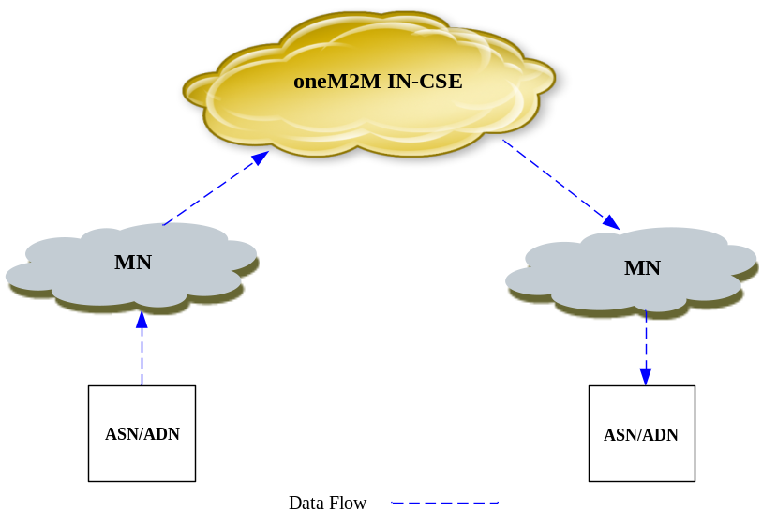
Figure 6.1-1: Data Exchange within oneM2M System
For specific scenarios, such as data exchange between different factories (the communication model is shown in the Figure 6.1-2). In this communication model, the M2M devices and MNs in factory A and factoryB reports topics, which it wants to publish or subscribe, to the DDS repository which is deployed on oneM2M service platform. The DDS repository establishs a pub-sub relationship according to the reported topics and the oneM2M architecure. If one M2M device in factory A wants to send data to a M2M device in factory B, the DDS repository can establish the pub-sub relationships between M2M devices and MNs, and between MNs and oneM2M service platform. The data exchange path is shown by the red dotted line in figure 6.1-2. This architecture can improve the central control capability of the platform.
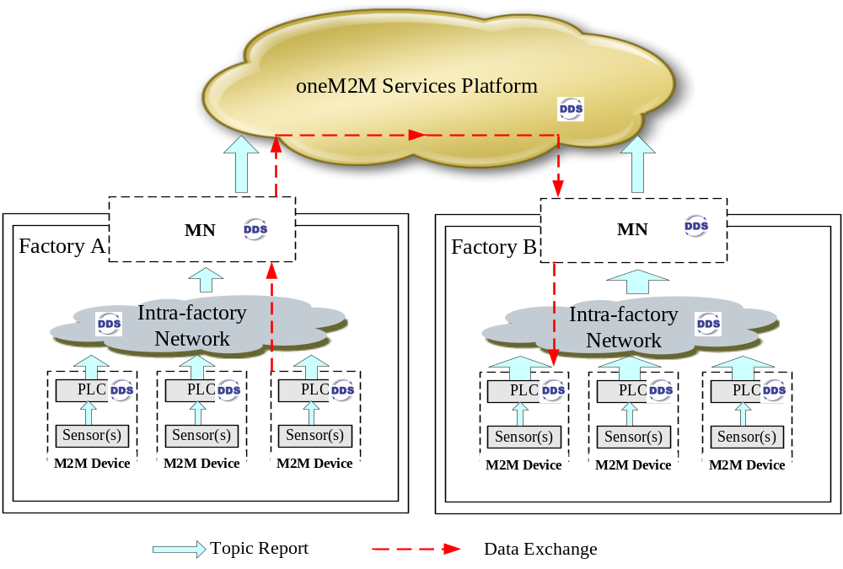
Figure 6.1-2: The communication model between different factories

6.2 Solution 1

6.2.1 Overview
This solution makes use of the Data Distribution Service protocol [i.5] and the RTPS [i.6] to transport serialized representations of oneM2M request and response primitives over the Mca or Mcc reference points, and provide reliable, real time communications
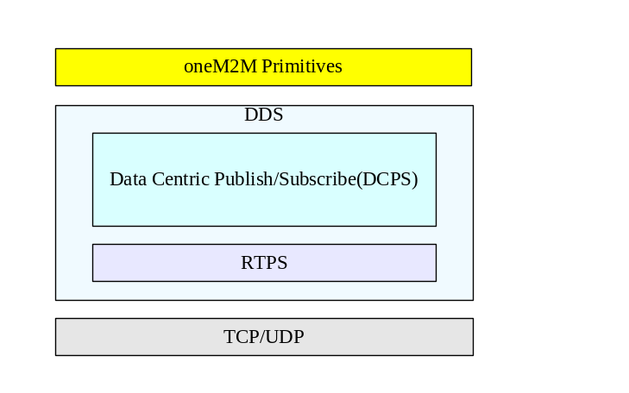
Figure 6.2.1-1: Protocol Stack
The protocol stack is composed of four parts:oneM2M Primitives DCPS, RTPS, and TCP or UDP, as shown in figure 6.2.1-1.
In order to better manage the topics, an central control mechanism is introduced. In the central control mechanism, the DDS repository which is an logical function module is introduced. The main role of the DDS repository is to establish the pub-sub relationship between oneM2M entities (AEs and CSEs) based on oneM2M architecture. After the pub-sub relationship is established, the oneM2M entities can directly communicate with each other without forwarding the data to the DDS repository.The communication between the publisher and subscriber do comply with the oneM2M architecture. The specific process and deployment of the DDS repository are presented in following sub-clauses.
There are two options for deploying the DDS repository:
- DDS repository is co-located within oneM2M nodes, and there may exist multiple repositories.
- DDS repository is deployed independently from oneM2M nodes.

6.2.2 DDS repository co-located within oneM2Mnodes
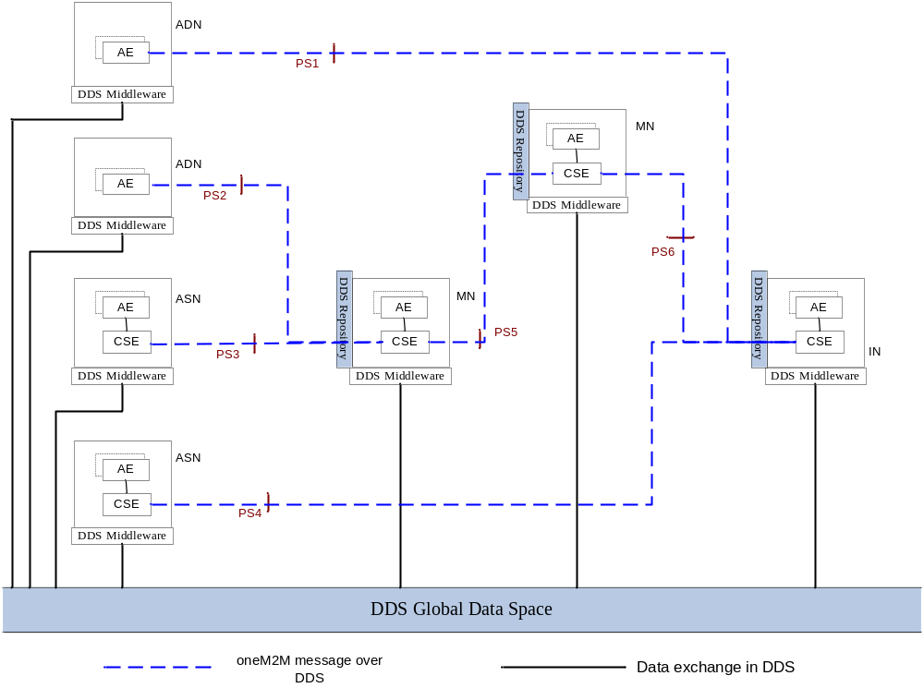
Figure 6.2.2-1: DDS repository co-located scenario
Figure 6.2.2-1 shows a protocol segment view of the DDS repository co-located scenario. In this scenario, all oneM2M nodes (ADN, ASN, MN, IN) include one or more DDS Middleware. DDS repositories are implement on MN and IN.
An oneM2M node sends its own information of topics to the DDS repository, which is pre-configured in the oneM2M node. The DDS repository can store the topic and manage the pub-sub relationship.
6.2.3 DDS repository deployed independently from oneM2M nodes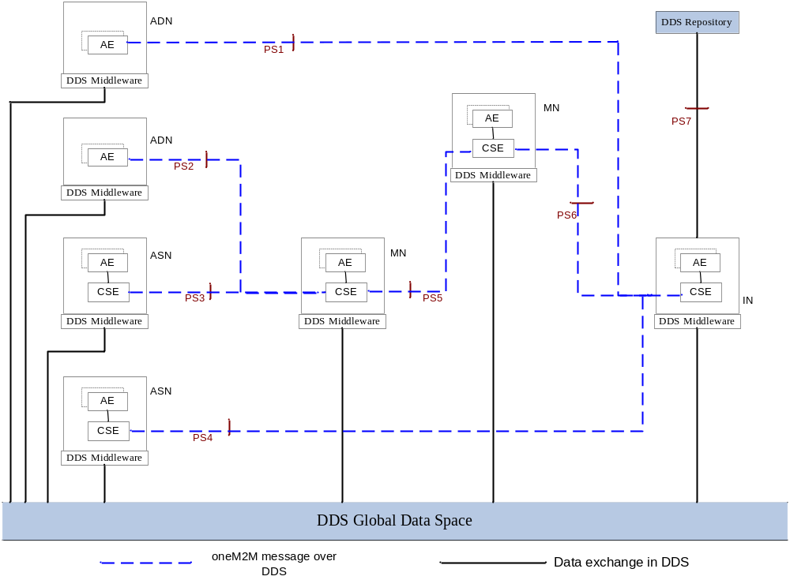
Figure 6.2.3-1: DDS repository located independently from nodes
Figure 6.2.3-1 shows a protocol segment view of the DDS repository located independently from nodes. In this scenario, all oneM2M nodes (ADN, ASN, MN, IN) include one or more DDS Middleware. DDS repository exists independently, which means the DDS repository is located outside of the nodes .The DDS repository acts MN/IN-CSE to communication with IN by Mcc interface. Editor’s note: whether PS7 is a oneM2M reference point or a DDS interface is FFS.

7 Possible Solutions for DDS based direct change of data between oneM2M entities

7.1 Senarios for DDS based direct change of data between oneM2M entities
(TBD)

7.2 Solution 1
(TBD)

8 Possible Solutions for oneM2M and DDS system interworking

8.1 Senarios for oneM2M and DDS system Interworking
(TBD)

8.2 Solution 1
(TBD)

9 Conclusion
(TBD)

Proforma copyright release text block
This text box shall immediately follow after the heading of an element (i.e. clause or annex) containing a proforma or template which is intended to be copied by the user. Such an element shall always start on a new page.
Notwithstanding the provisions of the copyright clause related to the text of the present document, oneM2M grants that users of the present document may freely reproduce the <proformatype> proforma in this {clause|annex} so that it can be used for its intended purposes and may further publish the completed <proformatype>.
<PAGE BREAK>

Annexes
Each annex shall start on a new page (insert a page break between annexes A and B, annexes B and C, etc.).
Use the Heading 9 style for the title and the Normal style for the text.
Annex <A>:
Title of annex (style H9)
<Text>
<PAGE BREAK>
Annex <B>:
Title of annex (style H9)
<Text>
B.1 First clause of the annex (style H1)
<Text>
B.1.1 First subdivided clause of the annex (style H2)
<Text>
<PAGE BREAK>

Annex <y>:
Bibliography
The annex entitled "Bibliography" is optional.
It shall contain a list of standards, books, articles, or other sources on a particular subject which are not mentioned in the document itself.
It shall not include references mentioned in the document.
Use the Heading 9 style for the title and B1+ or Normal for the text.
- <Publication>: "<Title>".
OR
<Publication>: "<Title>".
<PAGE BREAK>

History
This clause shall be the last one in the document and list the main phases (all additional information will be removed at the publication stage).
Publication history
V.1.1.1 | <dd Mmm yyyy> | <Milestone>

Draft history (to be removed on publication)
V.0.1.0 | 08-07-2016 | Includes agreed contribution at TP#24 meeting:  ARC-2016-0340-TR-0027-DDS usage in oneM2M skeleton
V.0.2.0 | 15-12-2016 | Includes agreed contribution at TP#25 meeting:  ARC-2016-0457R02- DDS backgrounds:add section 5  Includes agreed contribution at TP#26 meeting:  ARC-2016-0456R08-Senarios for DDS protocol binding with central control:add section 6

